How to update data using SQL

Make sure you added sql file to “/home/swpatil” folder on stage 1 server
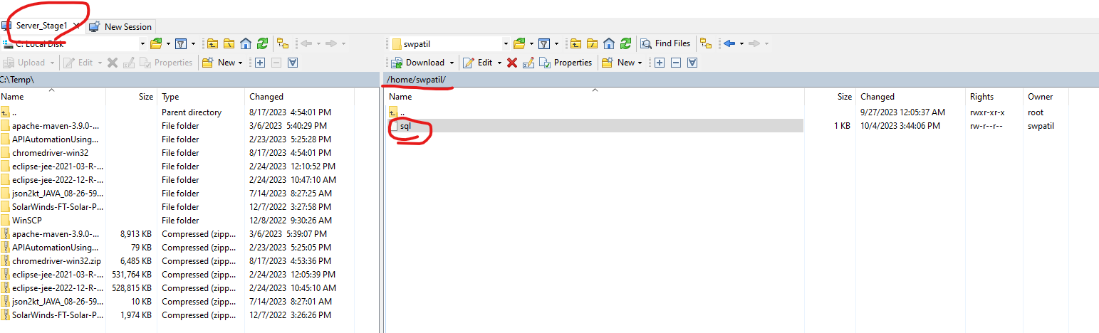

- Add your update SQL to above file.
- then one line space at the end (Note: New line needed after each sql)
- Then execute below script using putty on respective server i.e.stage 1

Stage 1: sudo -u backoff /stagefeeds/qa/bin/runsqlfile.pl --user=uii0qa@uiis01 --commit /home/swpatil/sql

Stage 2: sudo -u backoff /stagefeeds/qa/bin/runsqlfile.pl --user=uii0qa@uiis02 --commit /home/swpatil/sql

Stage 4: sudo -u backoff /stagefeeds/qa/bin/runsqlfile.pl --user=uii0qa@uiis04 --commit /home/swpatil/sql

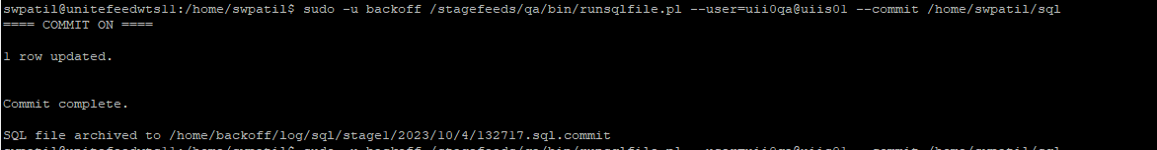

SFRP DB Update
- Create .SQL file
- Before updating anything you need to create SEQ_CHANGE_ID so use
select AST0CENTRAL.ASTRO_CENTRAL_UTILS.GENERATE_CHANGE_ID('Pkachhia_EE_Update3_OR') from dual;
SQL to get the new Seq ID & add this to your script as
UPDATE AST0CA.TS_ATC_TAX_1099R
SET CTL_REC_STAT = 'X', SEQ_CHANGE_ID = 413473003
WHERE PAYMENT_YEAR = 2024 AND CTL_REC_STAT = 'A';
- Save all these files to Home folder
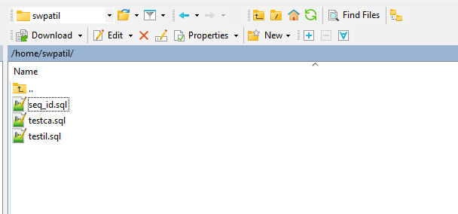

- sudo -u astrojob /astrofeedstage/qa/bin/runsqlfile.pl --user astqa0ca@asts02wtrw testsql7.sql --commit

select AST0CENTRAL.ASTRO_CENTRAL_UTILS.GENERATE_CHANGE_ID('Pkachhia_EE_Update3_OR') from dual;

sudo -u astrojob /astrofeedstage/qa/bin/runsqlfile.pl --user astqa0ca@asts02wtrw testca.sql --commit
sudo -u astrojob /astrofeedstage/qa/bin/runsqlfile.pl --user astqa0il@asts02wtrw testil.sql --commit

